1. Color theme (light, calming, pastel. Preferably blue or purple and a little bit of monochromatic theme)

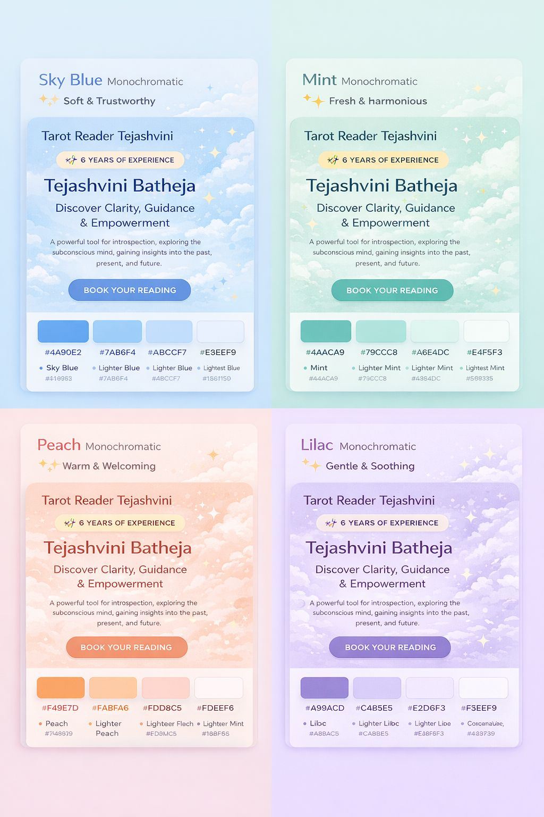

1. Home page- Change “Tejashvini Batheja” to “Tarot Card Reading” and change “A powerful tool” to “Tarot Is a Powerful….” Use this picture



1. About Me: Use this picture:

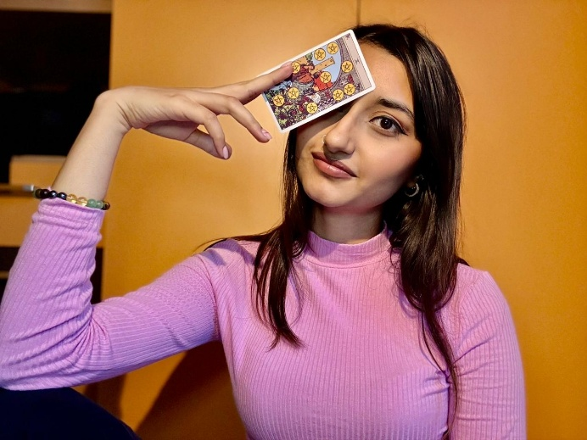

**Heading-** Guiding you towards clarity and purpose. **Description-** I’m Tejashvini Batheja, a professional tarot reader with 6 years of experience helping people navigate life with clarity and confidence.

I view tarot as a tool for insight and self-reflection, guiding you to understand your present situation, recognize patterns, and explore options that align with your goals. My focus is on helping you connect with your intuition and make choices that support your personal growth and well-being.

We make sure that each session provides a safe, respectful, and confidential space where your experiences and concerns are honored. I offer guidance that is honest, compassionate, and empowering, designed to help you navigate challenges and make the most of every situation.

Whether you’re seeking perspective, direction, or clarity, I’m here to support your journey and help you move forward with confidence.

1. Heading of services
2. Add “Book/ Book Now” icon in all the services.
3. Delivered Readings **–** Use this picture

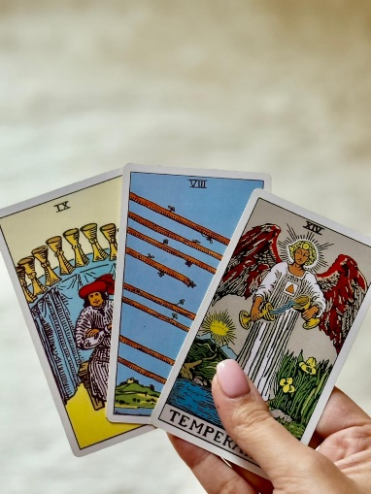

**Description:** - Get your questions answered through detailed written tarot readings delivered via email. Ideal for those who prefer to reflect on guidance at their own pace.

✦ Predictions, guidance, counseling & remedies

✦ Angel guidance & love messages

✦ Written responses & clear insights

✦ 2 follow-up questions included

✦ Delivered within 48 hours

**Form Details:**

* Name*
* Dob* (make a restriction that only above 18 can book in the calendar)
* Gender*
* Session Type* (3 ques or 5 ques option)
* Reading focus* (love, career and finance, other/ mixed)

(Add a small note under the reading focus: Questions related to serious health conditions/ illnesses are not applicable)

* Partner’s/ another person’s name (if applicable)
* Their DOB (if available)
* Questions* (300 words)
* Description of your situation* (500 words)
* **Add Terms & Conditions that are mandatory to select. (mentioned in point 13)**

1. Live readings- Use this picture

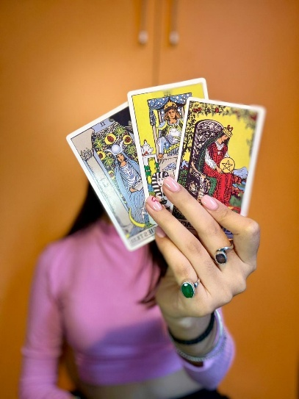

**Description**- Real-time tarot reading sessions via Zoom audio or video call, offering interactive and personalized guidance for your questions and concerns.

✦ Predictions, guidance & counseling

✦ Angel guidance & love messages

✦ Immediate clarity through live interaction

✦ 3 follow-up questions included

✦ Flexible scheduling

**Form Details:**

* Name*
* Dob* (make a restriction that only above 18 can book in the calendar)
* Gender*
* Session Type* (20 min or 40min option)
* Reading focus* (love, career and finance, other/ mixed)

(Add a small note under the reading focus: Questions related to serious health conditions/ illnesses are not applicable)

* Partner’s/ another person’s name (if applicable)
* Their DOB (if available)
* Choose your slot* (with date and time editable by me)
* Description of your situation* (500 words)
* **Add Terms & Conditions that are mandatory to select. (point 13)**

1. Aura Scanning- Use this picture



**Description-** A personalized energy assessment that provides a comprehensive report on your overall energy field.

✦ Overview of your energy field

✦ Assessment of all seven chakras

✦ Nazar Dosh (Evil Eye) & Bandhan / bonding Dosh (energetic bindings or blockages created by others)

✦ Remedies suggested if required

✦ Report delivered within 72 hours

**Form-**

Photo Guidelines for Aura Scanning

✦ Please upload a recent, clear photo of yourself.

✦ Plain background (preferably light-colored).

✦ Face should be clearly visible, no filters or heavy editing.

✦ Use the sample image as a reference while uploading your photo.



* Name*
* Picture*
* Email*

1. Testimonials Remove name and location and stars. Just the reviews.
2. Add these reviews:

* Hey Tejashvini, it’s been a few months since our session, and I can’t believe how accurate everything you said was! Thank you for your guidance—it really helped me stay on track.
* I was surprised by how accurate the chakra and energy report was. Your guidance helped me focus on areas I’d been neglecting and brought positive changes in my daily life.
* hey!

I just love your readings so much. It really helped me alot with all my anxiety stuff. I haven't seen my self with so much patience for a while but now i do. It really helped me to make a best decision for myself!!!

Thanks a lot

I really appreciate your efforts.

1. FAQ : No priority slot. Only emergency slot to be booked 24 hours in advance with 30% extra charges.
2. Payment options: UPI, Paypal, Razorpay, Bank transfer
3. **Terms & Conditions for Tarot Reading Services**

By booking a tarot reading session and proceeding with payment, you agree to the following:

1. Tarot Reading Guidance & Responsibility

• Readings are honest and reflect the most probable outcomes based on the cards.

• Your choices and actions influence outcomes; final results are your responsibility.

• Tarot readings are for guidance and self-reflection only, not a substitute for medical, legal, or professional advice.

2. Topics That Will Not Be Addressed

The following topics will not be predicted or discussed under any circumstances:

• Death or timing of death

• Critical or life-threatening health conditions

• Medical diagnoses or treatment advice

• Baby’s gender prediction

3. Rescheduling

• No refunds or reschedules are allowed if the client misses the session without notice.

5. Acceptance

• By booking and paying, you confirm that you have read, understood, and agreed to these Terms & Conditions.

1. FAQ: “ What type of ques can I ask”

You can ask about career, relationships, personal growth, spiritual development, and life decisions.

However, the following topics will not be predicted or discussed under any circumstances:

• Death or timing of death

• Critical or life-threatening health conditions

• Medical diagnoses or treatment advice

• Baby’s gender prediction

1. Please add this in FAQ

Rescheduling terms and conditions

• If you have an emergency, you may reschedule your session via email at least 24 hours in advance. Only one reschedule is allowed per booking.

If the reader must cancel due to an emergency, you may choose to either:

• Reschedule the session to a new date and time, or

• Receive a full refund

1. Please remove my phone number if it is possible. Only information for contact me should be via mail.
2. Here please change “Guiding you through…” to “Guiding you toward clarity and purpose”.

